CURRICULUM VITAE(CV)

A:PERSONAL PARTICULARS

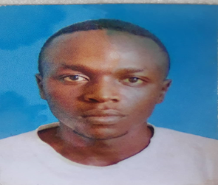SIR NAME: NYEMA

FERST NAME: MUDHIHIR

MIDDLE NAME: HAMIS

AGE: 22

SEX : MALE

MARITAL STATUS: SINGLE

STREET: MANZESE

REGION: DAR ES SALAAM

NATIONALITY: TANZANIA

B: CONTACT ADDRESS

Email**: nyemamudhihir@gmail.com**

Mob: +2550682131140

C. EDUCATIONAL BACK GROUND

|  |  |  |
| --- | --- | --- |
| **YEAR** | **INSTITUTION** | **AWARD** |
| 2021,Todate | Ardhi University | ---- |
| 2019,2021 | Bagamoyo Sec High School | Result Sleep |
| 2015,2018 | Nachingwea Day Secondary School | Certificate of Secondary Education |
| 2008,2014 | Ngunichile Primary School | Certificate of Primary Education |

D. WORKING EXPERIENCE

|  |  |  |
| --- | --- | --- |
| **YEAR** | **PLACE** | **WORKSHIP** |
| 2023 | TCB BANK | Industrial field Programmer |

**E.** LANGUAGE

* English written and well spoken
* Swahili written and well spoken

F. SKILLS AND ABILITY

Computer application

Php with laravel developer

Java Developer (Spring Boot + thymeleaf)

Html, Css, Bootstrap, JavaScript basics and Tailwind developer

Flutter Developer

G. HOBIES

* Computer programming

Systems, Webs and Application support

**H**. REFEREES

HAMIS SAID NYEMA, Mob: +2550719802510

EUNICE DAVID, Mob: +2550744170150

**I.**VERIFICATION

I certify that the above information contained in this document correctly described my qualification and myself only.

**Signature**

**M. H. Nyema.**